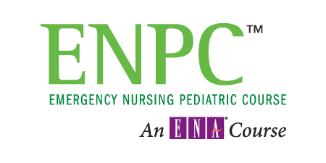

***INCREASE YOUR PAEDIATRIC KNOWLEDGE & ASSESSMENT SKILLS***

May 29 & 30, 2014

Chatham Kent Health Alliance,

Chatham, Ontario

0800-1700

0800-1600

Doug Jowett and Karen Laidlaw are Paediatric Nurses and Educators in the London Area with combined experience in Paediatric Critical Care, Paediatric Emergency, and General Paediatrics. ENPC provides a mix of hands on practice and didactic learning. Maximum participant to instructor ratio is 6:1.

Price is $425 + HST. This includes registration fees, new textbook, 2 days of instruction. Receipts are provided for submission to your workplace or RNAO Nursing Education Initiative for possible reimbursement.

ENPC – Emergency Nursing Pediatric Course

**Registration Form**

**Course Date**: May 29 & 30, 2014 **Start Time**: 0800 (registration 0745)

**Course Location**: Chatham Kent Health Alliance, Room TBA, Chatham, Ontario

Name: ________________________________________ (Please print)

Address: ______________________________________________________

Phone: ______________________________________________________

E-mail: _______________________________________________________

**It is required that course fees be paid in full upon registration. Cheques will be cashed no sooner than 2 weeks prior to the course. Registration fees are NON-refundable 2 weeks prior to the course. Cancellations prior to 2 weeks before the course will be refunded minus the cost of the textbook ($65.00). If the course is canceled due to lack of registrants (12 needed to run the course), the textbook can be returned if it is in its original state, otherwise the cost of the textbook will not be refunded.**

**Please make cheque payable to Doug Jowett**

**Registration Fees are $ 425.00 + 13% HST = $480.00**

Please send cheque and registration forms to:

Kathy-Lynn Stennett

Chatham Kent Health Alliance

Send inquiries to:

[kstennett@ckha.on.ca](mailto:kstennett@ckha.on.ca) or [djowett@rogers.com](mailto:djowett@rogers.com) or [kalaidlaw@sympatico.ca](mailto:kalaidlaw@sympatico.ca)