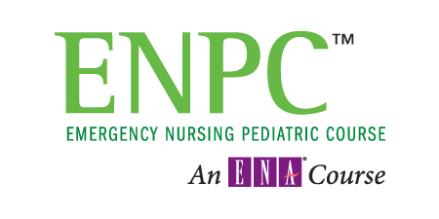

***INCREASE YOUR PAEDIATRIC KNOWLEDGE & ASSESSMENT SKILLS***

October 6 & 7, 2014

St. Joseph’s Hospital, London, Ontario

0800-1700

0800-1600

Instructors (maximum 6 students: 1 instructor):

Doug Jowett and Karen Laidlaw are Paediatric Nurses and Educators in the London area with combined experience in Paediatric Critical Care, Paediatric Emergency, and General Paediatrics.

ENPC provides a mix of hands on practice and didactic learning.

Cost is $425 + HST. This includes your registration, new textbook, 2 days of instruction, and lunch each day. Receipts are provided for submission to your workplace or RNAO Nursing Education Initiative for possible reimbursement.

ENPC – Emergency Nursing Pediatric Course

**Registration Form**

**Course Date**: October 6 & 7, 2014 **Start Time**: 0800 (registration 0745)

**Course Location**: St. Joseph’s Hospital, 268 Grosvenor St, Room B3-022 & B3-655, London, Ontario

Name: ________________________________________ (Please print)

Address: ______________________________________________________

Phone: ______________________________________________________

E-mail: _______________________________________________________

**It is required that course fees be paid in full upon registration. Cheques will be cashed no sooner than 2 weeks prior to the course. Registration fees are NON-refundable 2 weeks prior to the course. Cancellations prior to 2 weeks before the course will be refunded minus the cost of the textbook ($65.00).**

**Please make cheque payable to PedsPulse**

**Registration Fees are $ 425.00 + 13% HST = $480.00**

Please send cheque and registration forms to:

Doug Jowett

41 Davis Street,

Delaware, Ontario

N0L 1E0

Send inquiries to: [djowett@rogers.com](mailto:djowett@rogers.com) or [kalaidlaw@sympatico.ca](mailto:kalaidlaw@sympatico.ca)

The course has limited spaces; the first registrations received in the mail will be the first to be registered. Please make sure your e-mail is included on this form so that we can notify you when we have received your registration and if you are in the course or on the waiting list.

Business # 230868192