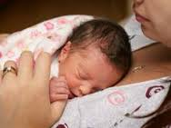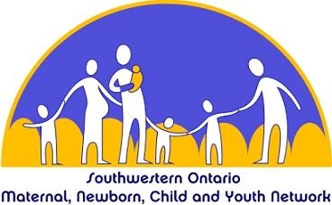

Videoconference Information:

This event is available ‘live’ on October 28th, and will be webcast and archived for viewing after that date.

To Participate:   
  
Contact the OTN site coordinator at your facility to reserve a room and videoconference enabled system (camera)

Telemedicine Coordinators:   
  
Please self-register through the Ncompass Public Events Calendar, or submit appropriate system information to: [scheduling@otn.ca](mailto:scheduling@otn.ca)

Website: <https://schedule.otn.ca/>

OTN Event ID: 46922580

Date: Oct. 28, 2015

Time: 1130-1400 hrs

Deadline for Registration:

October 27, 2015

For more information:

[Gwen.peterek@lhsc.on.ca](mailto:Gwen.peterek@lhsc.on.ca)

**October 28, 2015**

**1130-1400 hours**

Presenters



Dr. Kevin Coughlin

Neonatal Perinatal Medicine, Children’s Hospital

London Health Sciences Centre

Neonatal Co-Director, Perinatal Outreach Program



Dr. Henry Roukema

Neonatal Perinatal Medicine, Children’s Hospital

Medical Director of Nurseries

London Health Sciences Centre

Neonatal Consultant, Perinatal Outreach Program



Cindy Ulrich

Registered Dietician

Neonatal Intensive Care Unit, Children’s Hospital

London Health Sciences Centre



# **The Use of Probiotics and Human Donor Milk for Preterm Infants**

Hosted by:

The Southwestern Ontario Maternal, Newborn, Child & Youth Network (MNCYN) - Regional Perinatal Outreach Program

## You are invited to a Lunch & Learn presentation on: