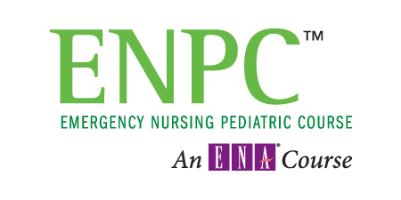

***INCREASE YOUR PAEDIATRIC KNOWLEDGE & ASSESSMENT SKILLS***

April 28 & 29, 2016

St Joseph’s Hospital,

London, Ontario

Room D1-226/228

Day 1: 0800-1730

Day 2: 0800-1600

Information and registration online at <https://pedspulse.simplesignup.ca>

Further information contact Doug Jowett at

[djowett@rogers.com](mailto:djowett@rogers.com)

Receipts are provided for submission to your workplace or RNAO Nursing Education Initiative for possible reimbursement.

*THANK YOU FOR CHOOSING PEDSPULSE*

*www.pedspulse.ca*

Business # 230868192