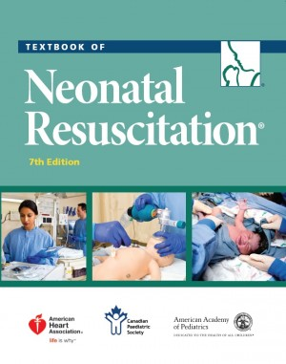

WE ARE NOW ACCEPING REGISTRATIONS

SPACE IS LIMITED, SO DON’T DELAY!

The Maternal, Newborn, Child & Youth Network (MNCYN)

Regional Perinatal Outreach Program

will be presenting

**NRP “New” INSTRUCTOR COURSE (7th Edition)**

at London Health Sciences Centre

**April 24, 2018**

For current NRP Providers who now wish to become instructors. Restrictions apply.

For more information, or to Register, go to <https://mncyn.simplesignup.ca/3024>, or go to our website [www.mncyn.ca/events](http://www.mncyn.ca/events)

Please share this information with your NRP providers and instructors.

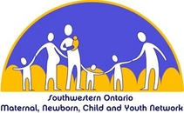Perinatal Outreach Program (MNCYN)