

HIGH TOUCH NURSING CARE

FOR WOMEN IN LABOUR

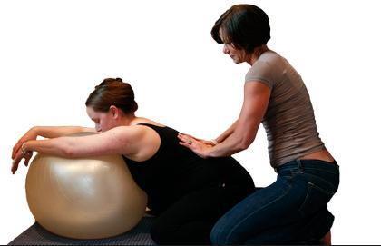

Presented by

GWEN PETEREK, BScN, PNC(C)

Perinatal Nurse Consultant

This workshop will focus on supporting women during labour and birth using a variety of comfort measures and positioning strategies. It is suitable for Labour/Birth nurses, and nursing students with an interest in perinatal nursing.

Date / Time: Tuesday, April 30, 2019

12:30 – 4:00 pm

Location: Huron Perth Healthcare Alliance – Stratford General Hospital

46 General Hospital Dr,

Stratford, ON N5A 2Y6

Room: E1- 609 A & B

Contact: Kathy Powers

Corporate Lead, Training and Development

Huron Perth Healthcare Alliance

Phone: 519-272-8210, ext. 2499

Email: kathy.powers@hpha.ca

Registration: Registration required (max 20 participants)

There is no fee for this workshop (lunch not included)