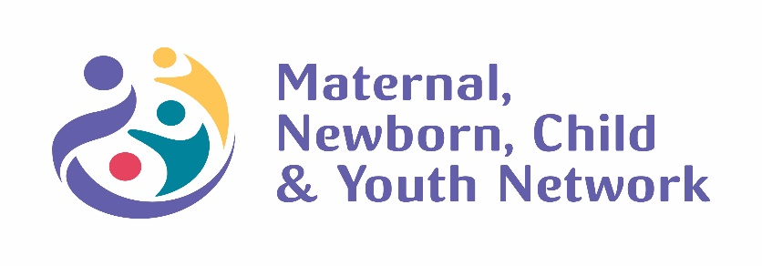

2019-2021
Strategic Plan
(Revised)
Keeping Care Close to Home

800 Commissioners Rd, PO. Box 5010, London, ON N6A 5W9

Who We Are
The purpose of the network is to enable the consistent delivery of safe, quality, maternal, newborn, child and youth care in the region by:
- Providing better health outcomes through systematic improvements in health promotion, illness and injury prevention, acute and follow up care and patient safety
- Providing better operational management through improved asset management within the organization and across the region, resulting in a greater return on investment
- Providing better systems integration through improved communication, program planning and support, resulting in greater coordination across the region and . . .
- Enhancing the learning and growth of health care providers by promoting and advocating for a consistent standard of care throughout the region.

What we do
- Annual case reviews (annual for each organization 1 Perinatal/1Paediatric)
- Critical event reviews (when required)
- Simulation events (on request)
- Outreach nursing site visits (2 visit for every organization – 1 Perinatal/1 Paediatric)
- Pediatric monthly knowledge reviews
- Program reviews (Q5 years)
- Annual conference
- Level 2 nursery workshop (Q 5 years)
- Collaborative Quality Improvement initiatives (per strategic plan)

MNCYN Strategic Directions 2018-2021

Align and support the work of the Provincial Council for Maternal and Child Health
VBAC, Pre-Term Birth Prevention, Post-Partum Standards of Care, Pediatric In-Pt Levels of Care

Our strategic plan was reviewed and revised based on our regional partners and key stakeholders (see appendix A for participating organizations) in October 2019 at the Regional Steering Committee Meeting. The strategic priorities were determined by the feedback (themes) as voiced by our partners during site visits during the summer of 2019. The themes were then positioned under the strategic pillars of MNCYN, Quality Health Outcomes, Systems Integration, Improved Asset Management and Enhanced Learning and Growth.

Quality Health Outcomes

- Trauma and Violent Informed Care
Develop a strategy to support increased awareness and knowledge related to trauma and violent care. Include tools to support assessment of patients who may have experienced a traumatic event/experience and increase knowledge related to caring for patients who present for care.

- Intimate Partner Violence
Develop education opportunities to support greater awareness and knowledge in assessing and directly caring for patients and families who experience intimate partner violence.

System Integration

- Children and Family Services/Mandatory Reporting
Provide learning opportunities for clinicians to better understand their role and professional responsibility to report suspected and or confirmed abuse.

- List of Policies required for Maternal- Newborn, Paediatrics and NICU/SCN
Develop a list of policies that organizations should consider for their maternal/newborn, paediatric and NICU/SCN.

Improved Asset Management

- Standardized orientation - Perinatal
Develop a standardized orientation program for all partners to access. This will include perinatal and pediatric. It will be modular based and provided on an online learning platform. It will include competencies and tools to support preceptors.

- Standardized orientation – Paediatric (expand)
Develop a standardized orientation program for all partners to access. This will include perinatal and pediatric. It will be modular based and provided on an online learning platform. It will include competencies and tools to support preceptors.

Enhanced Learning and Growth

- Provide outstanding education opportunities/workshops/simulations
Nursing education visits, Case reviews, Critical event reviews, ACORN, NRP, FHS, Level 2 nursery course, labour support workshop, conference. Plan simulation events with regional partners. Work with
partners to determine educational needs. Continue to track events and number of attendees.

- Experiential Learning
Finalize the agreement to support staff from SW region to access hands on training through LHSC. Develop internal process through LHSC to determine intake process and tracking. Develop outcome measures to determine impact on quality/services

MNCYN Accountability & Operational Structure 2018-2021

Patients and Families of the SW Region
Partner Organizations – Memorandum of Understanding
London Health Sciences Centre
Regional Steering Committee

Regional Executive Committee

Operations

Partner Engagement

Regional Nurse Leaders Meeting

MNCYN Committee’s and Working Groups

MNCYN Leadership Team
MNCYN Executive Director MNCYN Medical Co-Director - Maternal
MNCYN Medical Co-Director Lead - Neonatal MNCYN Medical Co-Director - Pediatrics
PCA Working Group QA working Group(s)
National Fetal Health Surveillance Steering
Medical Leadership Meeting LHSC Medical Directors NICU
Peds Perinatal
Outreach Program Staff Perinatal Nurse Consultant
Pediatric Nurse Consultant Administrative Assistants

Provincial Council for Maternal Newborn, Child and Youth Health

External

Internal and External Internal
1- See following page for descriptions of committee’s and accountabilities.
Consultant Groups
Canadian Perinatal Partnerships Children’s Treatment Centers SOGC
CPS BORN CAPWHN PCMCH NRP
National Center on Shaken Baby syndrome ACORN
Trekk

Executive Committee
  - In order to facilitate the operations and management of the Network, an Executive Committee will be formed to represent the Regional Steering Committee. The Executive Committee will report to the Regional Steering Committee at minimum semi-annually, or more often when necessary.
Meeting Quarterly

Partner Organizations (MOU)
  - This MOU is designed to serve as a framework to inform and guide the on-going working relationship between the South Western Ontario Maternal, Newborn, Child and Youth Network (hereafter referred to as the
“Network”) sponsored by London Health Sciences Centre and partner hospitals, Community Care Access Centers
and Public Health units (hereafter referred to as the “Partners”).
  - All parties have agreed to enter in the Agreement for the purpose of defining their roles and responsibilities, including financial, in the formation and operation of the Network.

Regional Steering Committee
  - Reporting to the Partner organizations’ CEO/ Medical Officer of Health, the Network Regional Steering Committee will make strategic decisions as they apply to the Network and will plan for the successful evolution of program developments in Southwestern Ontario as agreed to by the Partners. The Regional Steering Committee will ensure that the key goals, vision and mission of the Network are consistent with the direction of the Ministry of Health and Long-Term Care, the Ministry of Health Promotion and the Ministry of Children and Youth Services, nationally recognized best practice standards, and the needs of The Partners and other stakeholders. Additionally, the Regional Steering Committee will review reports and recommendations resulting from the work of the Task and Working Groups. The Regional Steering Committee consists of one voting member from each Partner organization.
Meeting bi-annual.

- Committees/workgroups
  - Created to address strategic priority areas as they are identified.
  - These are time limited committees to address specific deliverable/projects
  - These committees and groups are volunteer based with key stakeholders and TOR with deliverables

Medical Leadership Meeting
  - Created to update medical leadership on current state of MNCYN initiatives
  - Support communication between partner organizations and medical leadership
  - Creates a forum to better understand the complexity of children received through LHSC to inform educational/follow up with regional centers
Meeting monthly

Regional Nurse Leader Meeting
  - Created to ensure nursing leadership engagement and voice in regional maternal newborn and pediatric priorities.
  - A forum to understand regional challenges and opportunities
  - Knowledge translation and development
Bi-annual meeting

